EARTHQUAKE PREDICTION MODEL BY USING PYTHON
PHASE 2:INNOVATION
EARTHQUAKE PREDICTION FLOW CHAT
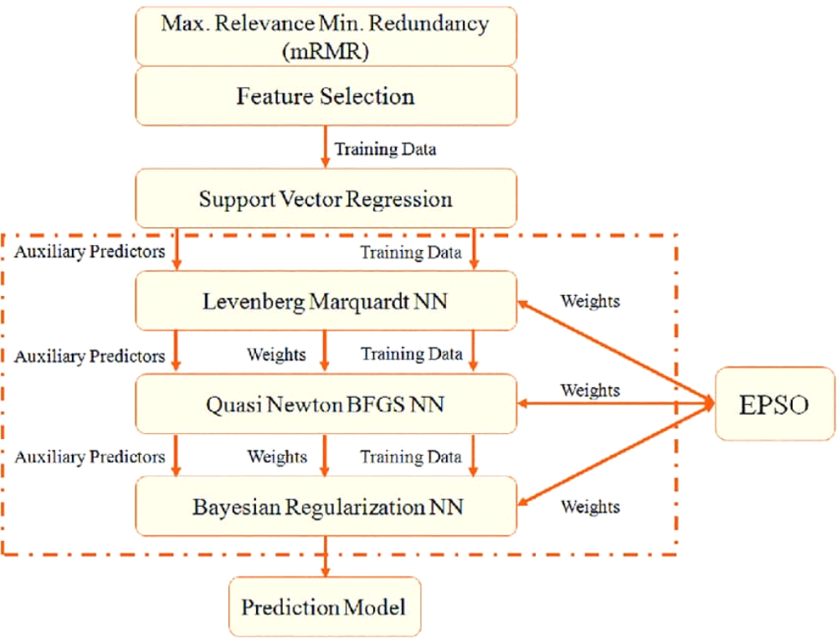

Introduction:
To improve the performance of a prediction model for earthquakes, you can
apply advanced techniques like hyperparameter tuning and feature engineering.
Hyperparameter
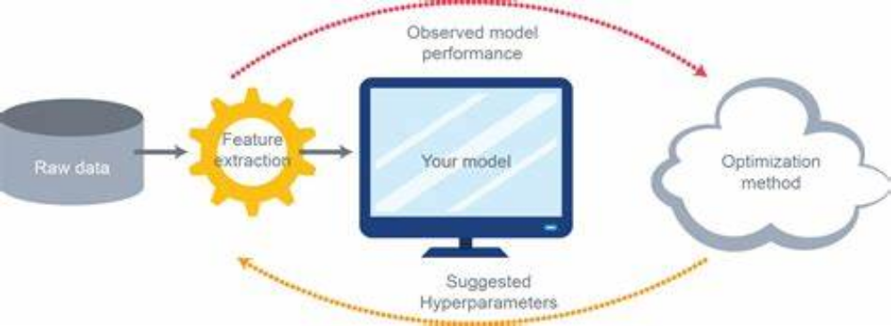

> Use techniques like grid search or random search to systematically search through
different combinations of hyperparameters for your model.
> Focus on hyperparameters specific to the chosen algorithm, such as learning rate,
number of hidden layers or units in a neural network, depth of decision trees, etc.
>Utilize tools like cross-validation to assess the performance of different
hyperparameter configurations
Random Search
Random search is another valuable technique for hyperparameter tuning in
machine learning models, including those used for earthquake prediction.
1. Select a Model:
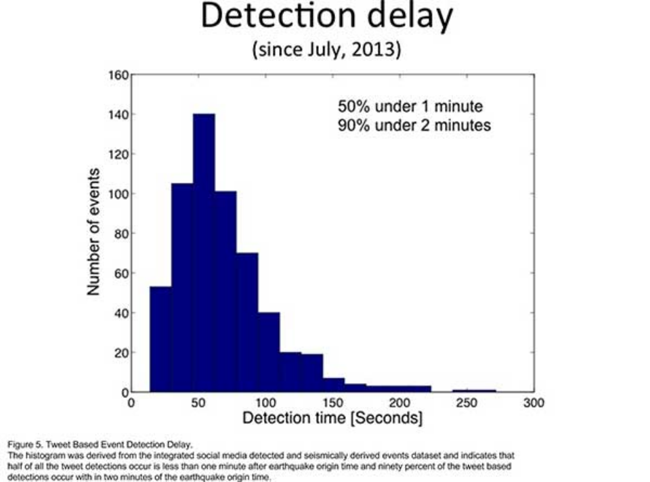

>Choose the machine learning or deep learning model you want to use for
earthquake prediction.
>This could be a decision tree, random forest, support vector machine,
neural network, or any other suitable model.
2. Define Hyperparameter Ranges:
>Identify the hyperparameters of your chosen model that you want to
tune. For earthquake prediction, these hyperparameters might include the learning
rate, number of layers and units in a neural network, regularization strength, or
kernel parameters for support vect
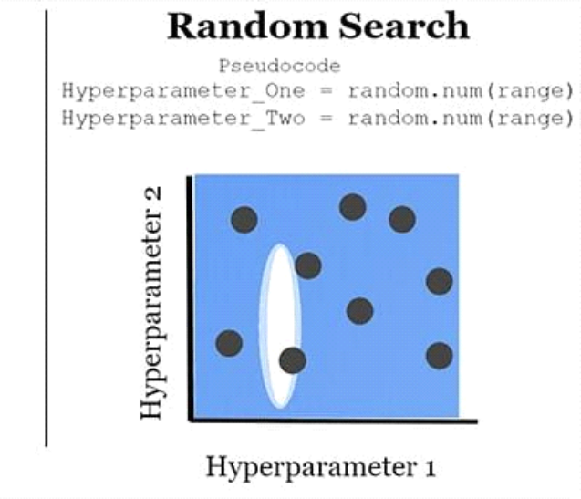
or machines. Define ranges or distributions for
each hyperparameter that you want to explore.
3. Split Data:
>Divide your earthquake dataset into training, validation, and test ets.
The training set is used to train the model, the validation set helps in
hyperparameter tuning, and the test set is used for final evaluation.
4. Random Search:
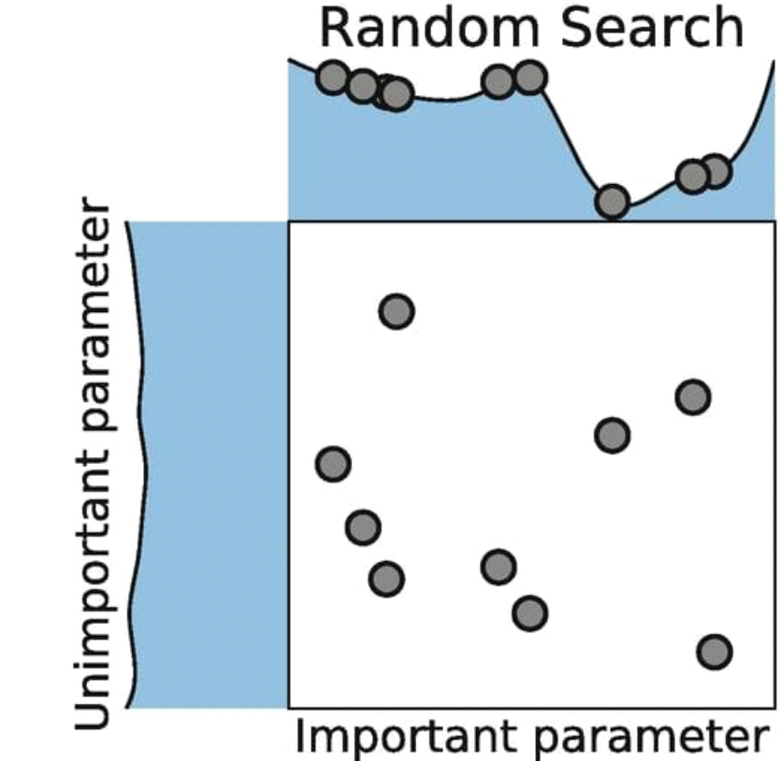
> Instead of systematically exploring all possible combinations like grid
search, random search randomly selects hyperparameter combinations from the
defined ranges. It samples hyperparameters according to a specified distribution
for each hyperparameter.
5. Cross-Validation:
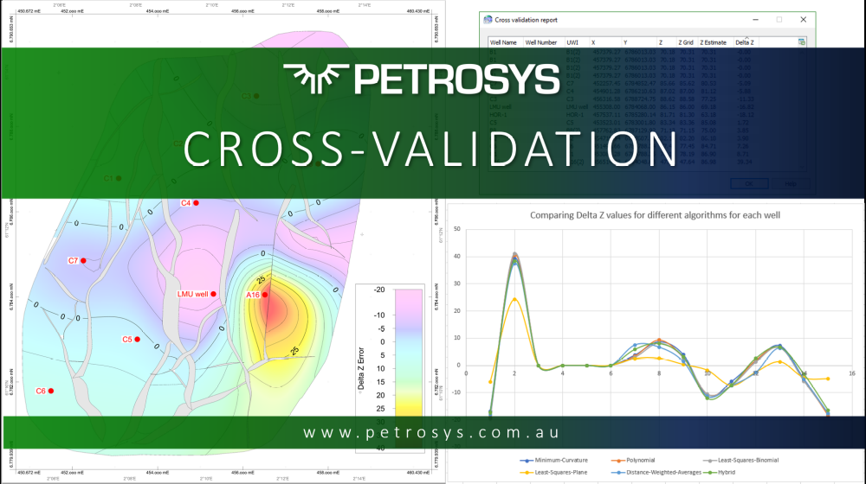

>Perform cross-validation on each randomly selected hyperparameter
combination to evaluate model performance and prevent overfitting.
6. Evaluate Performance:
>Use a suitable evaluation metric for earthquake prediction, such as
Mean Absolute Error (MAE), Mean Squared Error (MSE), or a domain-specific
metric if available. The metric should reflect the accuracy and precision of
earthquake predictions.
7. Select Best Hyperparameters:
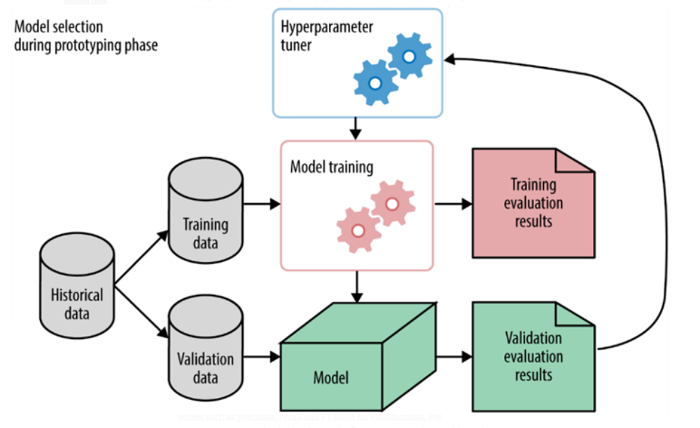

>After running multiple random combinations, choose the combination
that yielded the best performance on the validation set.
8. Final Model Training:
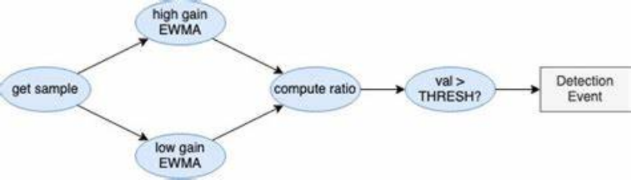

>Train a final model using the selected hyperparameters on the entire
training dataset (including the validation set).
9.Model Evaluation:
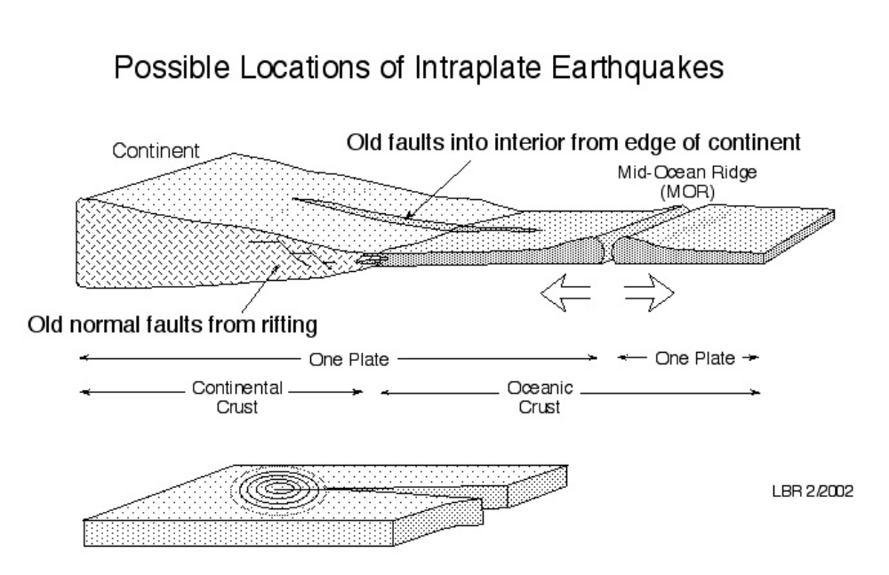

>Assess the final model's performance on the test dataset to get an
unbiased estimate of its predictive accuracy.
10. Iterate if Necessary:
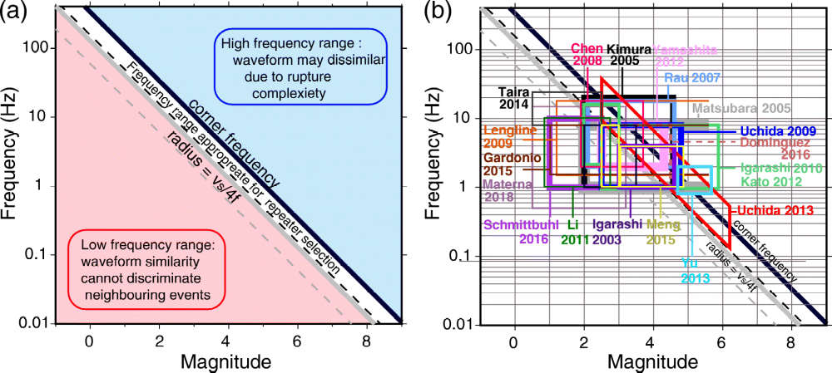

> If the model's performance is not satisfactory, you can repeat the
random search process with a larger number of trials or explore additional
hyperparameters. Continue iterating until you achieve the desired level of
prediction accuracy.
For the instance,consider the following python source program
CODING
Python program:
import numpy as np
from sklearn.datasets import load_iris
from sklearn.ensemble import RandomForestRegressor
iris = load_iris()
rf=RandomForestRegressor(random_state=35)
X = iris.data
y = iris.target
n_estimators = [int(x) for x in np.linspace(start = 1, stop = 20, num = 20)]
max_features=[auto,sqrt]
max_depth = [int(x) for x in np.linspace(10, 120, num = 12)]
min_samples_split = [2, 6, 10]
min_samples_leaf = [1, 3, 4]
bootstrap = [True, False]
random_grid = {n_estimators': n_estimators,
max_features': max_features,
max_depth': max_depth,
min_samples_split': min_samples_split,
min_samples_leaf': min_samples_leaf,
bootstrap': bootstrap}
rf_random = RandomizedSearchCV(estimator = rf,
param_distributions = random_grid,
n_iter = 100, cv = 5, verbose=2, random_state=35, n_jobs = -1)
rf_random.fit(X,y)
print ('Random grid: ', random_grid, '\n')
print(Best parameters:,rf_random.best_params_,\n)
Output:
[Parallel(n_jobs=-1)]: Done 500 out of 500 | elapsed: 3.6s finished
Random grid:
{n_estimators': [1, 2, 3, 4, 5, 6, 7, 8, 9, 10, 11, 12, 13, 14, 15, 16, 17, 18, 19, 20],
max_features': ['auto', 'sqrt'], 'max_depth': [10, 20, 30, 40, 50, 60, 70, 80, 90, 100,
110, 120], 'min_samples_split': [2, 6, 10], 'min_samples_leaf': [1, 3, 4], 'bootstrap':
[True, False]}
Best Parameters:
{n_estimators': 10, 'min_samples_split': 10, 'min_samples_leaf': 4, 'max_features':
auto', 'max_depth': 70, 'bootstrap': True}
FeatureEngineering:
>Gather relevant domain knowledge or consult with experts to identify
potentially important features related to earthquake prediction.
> Create new features based on existing data, like temporal features (time of
day, day of the week, seasonality) or spatial features (distance to fault lines, geological
characteristics).
> Experiment with various feature selection techniques to identify the most
informative attributes and reduce dimensionality if needed.
>Consider using domain-specific feature engineering methods tailored to
seismology or geophysics.
Deployment:
> Once you have a well-tuned model, you can deploy it for real-time earthquake prediction,
continuously monitoring incoming seismic data and providing alerts when necessary.
CONCLUSION:
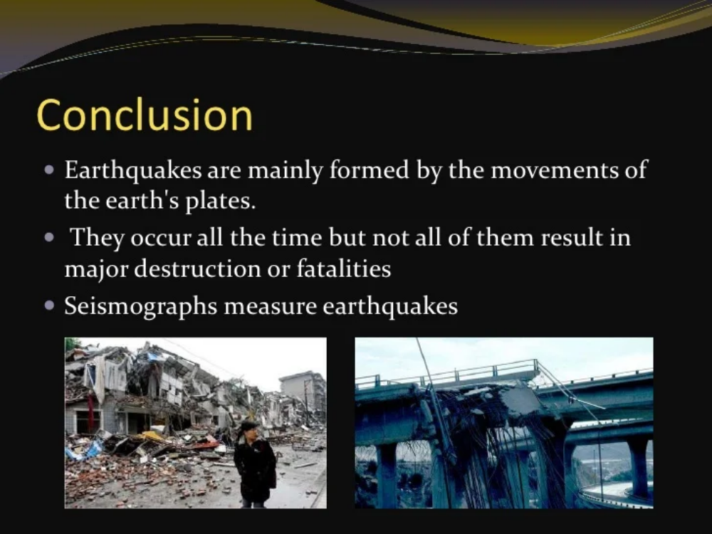

>These innovations are part of ongoing efforts to improve earthquake prediction,
enhance early warning systems, and ultimately reduce the impact of seismic events on
communities and infrastructure. While predicting earthquakes with high precision remains a
complex challenge, these approaches aim to provide valuable insights and advance our
understanding of seismic activity

